Dear Year 7 & 8 Students of Bromsgrove International,

The UKMT have made the Junior Mathematical Challenge 2020 available online, in response to our school closure. This means you can sit the Challenge at home.

The date that we will be taking part in this challenge is the Wednesday 24th June, start 12pm and you will need to click on this link to access the challenge challenges.ukmt.org.uk on the day.

Before the day I will send you a username and password to use to take the Challenge. In the meantime you can click on the link to take some practice questions.

Please follow the steps below to do this:
- Open a browser and go to the site challenges.ukmt.org.uk/
- Click on Challenges
- Under Practice, click JMC 2019 Questions

Any questions please do not hesitate to contact your Mathematics teacher,

Kind regards & Good Luck!

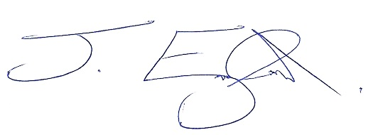
Mr. Jonathan England.
Head of Mathematics.

